Charts

Create Charts
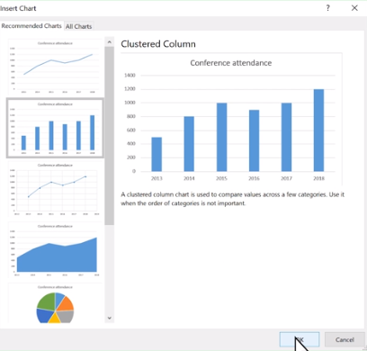
Charts help you visualize your data in a way that creates maximum impact on your audience. Learn to create a chart and add a trendline.
Create a chart
- Select the data for your chart.
- Select Insert > Recommended Charts.
- Select a chart on the Recommended Charts tab, to preview the chart.

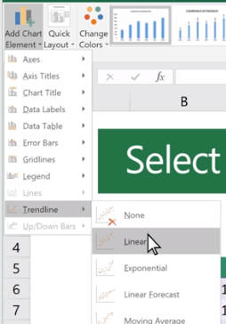
Note: You can select the data you want in your chart and press ALT + F1 to create a chart immediately, but it might not be the best chart for the data. If you don’t see a chart you like, select the All Charts tab to see all chart types.
- Select a chart.
- Select OK.
Add a trendline
- Select a chart.
- Select Design > Add Chart Element.
- Select Trendline and then select the type of trendline you want, such as Linear, Exponential, Linear Forecast, or Moving Average.

Add a chart title
Add a title to your chart to make it easier to understand.
Add a chart title
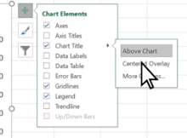
- In your chart, select the "Chart Title" box and type in a title.
- Select the plus sign.
- Select the arrow next to Chart Title.
- Select Centered Overlay to lay the title over the chart, or More Options for additional choices.
- Right-click the chart title to format it. with options like Fill or Outline.

Update a chart title
- Select a chart title.
- Add an equal sign to the formula bar.
- Select the cell you want to link any title changes to.
- Press Enter.

Show or hide a chart legend
Show a legend to add more context to your chart data, or hide it to give it a clean look.
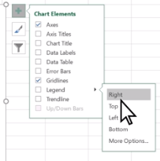
Show a chart legend
- Select a chart and then select the plus sign.
- Select Legend and select the arrow next to it.
- Choose where you want the legend to appear in your chart.
- Select Secondary Axis for the data series you want to show.
- Select the drop-down arrow and choose Line.
- Select OK.

Hide a chart legend
- Select a legend to hide.
- Press Delete.

Add a secondary axis
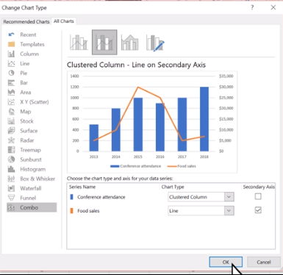
Add a secondary axis to your chart to show different values than the original axis.
- Select a chart to open Chart Tools.
- Select Design > Change Chart Type.
- Select Combo > Cluster Column - Line on Secondary Axis.
- Select Secondary Axis for the data series you want to show.
- Select the drop-down arrow and choose Line.
- Select OK.

Analyze your data quickly
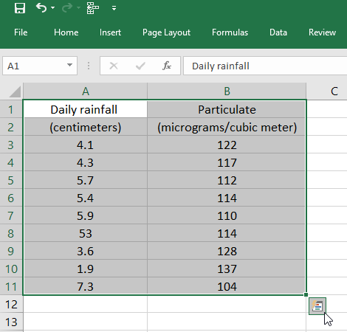
Excel's Quick Analysis button lets you instantly create different types of charts, including line and column charts, or add miniature graphs called spark lines.
- Select a range of cells.
- Select the Quick Analysis button that appears at the bottom right corner of the selected data.
Or, press Ctrl + Q.
- Select Charts.
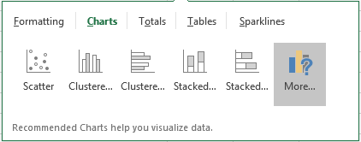
- Hover over the chart types to preview a chart, and then select the chart you want.

Change the source for a chart
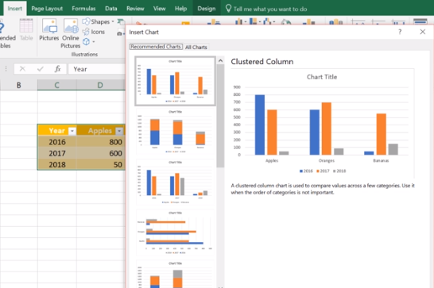
If you need to change data in a chart, you can do it from its source.
Create a chart from a table
- Select the cells you want to use.
- Select Insert > Recommended Charts.
- Select the chart type you want, and select OK.
Update a chart source
- With your table linked to a chart, make updates in your table and you'll see the changes reflected in the chart.

Use Sparklines to show data trends
Sparklines are mini-charts placed in single cells, to show visual data trends. You can quickly add and format a Sparkline chart in your worksheet.
Add a Sparkline
- Select a blank cell at the end of a row of data.
- Select Insert and pick Sparkline type, like Line, or Column.
- Select cells in the row and OK in menu.
- More rows of data? Drag handle to add a Sparkline for each row.
Format a Sparkline chart
- Select the Sparkline chart.
- Select Design and then select an option:
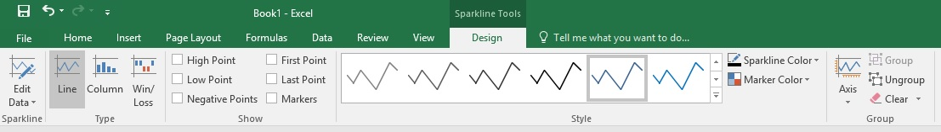
  - Select Line, Column, or Win/Loss to change the chart type.
  - Check Markers to highlight individual values in the Sparkline chart.
  - Select a Style for the Sparkline.
  - Select Sparkline Color and the color.
  - Select Sparkline Color > Weight to select the width of the Sparkline.
  - Select Marker Color to change the color of the markers.
  - If the data has positive and negative values, select Axis to show the axis.

